Providence Christian School
Box 240, 615 Queen Avenue
Monarch, AB, T0L 1M0
403-381-4418 Fax: 403-381-4428
admin@pcsmonarch.com www.pcsmonarch.com

Mr. H. VanderHoek - Principal
e-mail: principal@pcsmonarch.com

Miss A. Feyter - Assistant-Principal
e-mail: assistantprincipal@pcsmonarch.com

Student Handbook 2023 / 2024

Principal’s Message

Welcome to a new school year at the Providence Christian School.

School is a place of learning, a place where you gain knowledge and insight and where you develop skills and attitudes that will be important to you for a lifetime.
School is also a place of interactions and relationships. You have been created for community and fellowship. This is what family and church are about, and the school similarly challenges you to live in community in a wholesome and godly manner.
You can do this because you have been given much.
Not many children and youths your age in the world have the accumulation of benefits and blessings that you enjoy. Freedom and opportunity to attend a Christian school is a rare gift today that many wish for but do not have. You are particularly favoured by the Provident care of your Creator. There is much reason for gratitude. “It is a good thing to give thanks unto the Lord, and to sing praises unto thy name, O Most High.” Psalm 92.
We encourage you to use your time and opportunities this year in God’s service, as a a work of gratitude to our Him who loves and blesses you.

This handbook has been developed to help you and your parents to know about school policies, procedures and schedules that can help you enjoy good relationships and do well in your work.
God places us in a community of travelers who journey together toward the city that is built on a hill; the city of God. In our travels we need each other for learning and support, for growth, encouragement, and correction. I pray that our greatest allegiance and dedication this year will be to our Master in whose footsteps we walk.

Mr. VanderHoek, August 2023.

Mission Statement
The mission of the PCS Board, in collaboration with the PCS Society, is to further the cause of Christian education in general and, more particularly, to conduct in its own community a school system which will provide a weekday Christian instruction and education which the applicants deem necessary for covenant children in order that such children may be true Christians and occupy worthily their places in society, church, and state. All curricular requirements of the Department of Education in the Province of Alberta are fulfilled, and all institutional and physical facility requirements are met.

Vision
PCS is a Christian day-school which offers Alberta Curriculum from a Christian perspective in order to train students to become responsible citizens who are true Christians and who will occupy their places in society, church and state in a manner worthy of Christ.

Beliefs
Providence Christian School was set up for committed Christian parents who are serious about extending the Christian nurture for their children into their education. We seek to be obedient to God’s command to us to pass onto the next generation His decrees, laws and mighty deeds (Deuteronomy 6 and Psalm 78). We believe that the home and school must work closely together to educate our children so that what is taught and believed in the home is reinforced at school. Since we believe that children are image bearers of God, we seek to have them educated in a safe, secure and caring environment where they are respected and valued. Our aim is to develop within the students strong reading, writing and math skills so that they will be able to analyze data and develop ideas and inferences. We strongly believe that Christ-centered education is an essential building block of our society’s future.

General School Information

Teacher | Home room | Teaching responsibilities | Room
Nancy VandenBrink | Kindergarten | Kindergarten | 104
Kathleen Bolink | Grade 1 | Grade 1 | 113
Janelle Hamman | Grade 2 | Grade 2, ELA 6 | 112  110
Michelle Agenbacht | Grade 3 | Grade 3 | 109
Rachelle Nieboer | Grade 4 | Grade 4, Choir | 107
Jaylene Reitsema | Grade 5 | Grade 5, Math 7 | 108
Charlene Heins | Grade 6 | Grade 6, Choir 5-12 | 110
Brittany Prestage | Grade 7 | PE K-12, Health 2,3, 4, Athletic Director | 400  106
Arnold Entz | Grade 8 | ELA 7, ELA 8, ELA 9, Social St 7, Social St 8, Bible 6 | 303
Cheryl Imanse | Grade 9 | Science 7, 8, 9, 10, Math 8, 9, Social St 9, Athletic Director, | 302
Merrick Dennill | Grade 10 | Math 8, 10, 20, 30, Bio 30, Chem 20, ELA 10, Social St 10 | 304
Bert Mourits | Grade 11/12 | Bible 7, 8, 9, 10, 11, Social 20, 30 | 301
Angela Feyter |  | CALM 10 | 115
Hugo VanderHoek |  | Visuals Arts 7-12, | 115
Marvin van den Hoek |  | Woodworking 7-12 | 500
Judy Reath |  | Special Education Coordination | …

Support Staff
Mrs. D. Oostlander Administrative Assistant
Mrs. K. Van EedenPetersman Financial Administrator (PT)
Mrs. G. Weststrate Educational Assistant (PT)
Mrs. A. Oudshoorn Educational Assistant (PT)
Mrs. C. Gruninger Educational Assistant (PT)
Mrs. P. Veldman Educational Assistant (PT)
Mrs. M. Dekker Special Educational Assistant
Mrs. A. Mazereeuw Special Educational Assistant
Mr. R. Shields Bus Driver – Ft. Macleod (Blue)
Mr. R. Smith Bus Driver – Coaldale (Orange)
Mr. B. Sommers Bus Driver – Picture Butte (Red)
Mr. R. Traber Bus Driver – Granum / Nobleford (Green)
Mrs. A. Macintosh Custodian
Mrs. K. Van EedenPetersman Financial Administrator (PT)

Bell Schedule ~ Elementary | Bell Schedule ~ Jr. High/ Sr. High
School begins 8:20  Recess 9:56 – 10:11  Lunch 11:45 – 12:30  Recess 2:00 – 2:15  Dismissal 3:40 | School begins 8:20  Homeroom 8:20 - 8:40  Transition 10:12 – 10:18  Lunch 11:50 – 12:32  Transition 2:03 – 2:09  Dismissal 3:40

Academic Standards

Elementary & Jr High | Sr High Grade Scale
97-100% | 85-100% | Excellent | A+
93-96% |  |  | A
90-92% |  |  | A-
87-89% | 75-84% | Good | B+
83-86% |  |  | B
80-82 |  |  | B-
77-79% | 60-74% | Acceptable | C+
73-76% |  |  | C
70-72% |  |  | C-
67-69% | 50-59% | Poor | D+
63-66% |  |  | D
60-62% |  |  | D-
Below 60% |  | Unacceptable | E
Below 50% | Below 50% | Failing | F
Junior High students move on to the next grade level at the end of the academic year, unless too many courses and/or critical courses have not been completed. Some students may then need to repeat the entire year. Some students may be prevented from taking certain courses, in following years, unless they successfully redo a failed course on their own during the summer (summer school). As a rule, failing more than 2 courses will require successful completion of a summer school course.
Promotion from grades 10, 11, and 12 depends on having accumulated sufficient credits to satisfy the Ministry of Education and Providence Christian School graduation requirements.

All assignments that are to be handed in should be typed or written with ink unless otherwise instructed by the teacher. Teachers may use their discretion in having students re-do assignments which are very poorly done.

Late Assignment Penalties
One day late – earned percentage grade reduced by 10% (eg. if the student earns 75% on the assignment, they will receive a score of 65%)
Two days late – earned percentage grade reduced by 20%
Over two days late – earned percentage grade will be reduced by half (eg. if the student earns a grade of 60%, they will receive a score of 30%)
Study hall will be assigned for late assignments, starting on the first day late and continuing until the assignment is completed.

For short term absence, students will be given two days to make up class work unless otherwise agreed to by the teacher. Assignments which were due during the student’s absence will be due on the first day back.
If parents know that a student will be absent for three or more consecutive days, they must contact the school office or principal two weeks in advance. If the student is able to complete some work, teachers may, but are not obliged to prepare a work package that parents can pick up during or prior to the absence. These assignments are due upon the students return to school. If the office does not receive notice two weeks before the absence, no assignments will be collected. Students who have an unexcused absence will not receive any make-up assignments.
The Alberta Diploma Exams count as 30% of the final mark for Grade 12 students. Additional school final exams for Grade 12 are optional, and if set, count as no more than 10% of the year’s classroom work. A final exam may be required in other grades at the teacher’s discretion and will count for no more than 30% of the final mark.

Honour Students
Honorable academic achievement is recognized at the end of the year.
- B Honour status is awarded to Jr. High students whose GPA is 80-89%
- B Honour status is awarded to Sr. High students whose GPA is 75-84%.
- A Honour status is awarded to Jr. High students whose GPA is 90-100%
- A Honour status is awarded to Sr. High students whose GPA is 85-100%.
Honour status is not awarded if a student fails any course.

Attendance
PCS holds to a Christian perspective on attendance, punctuality, and responsibility. Education has priority over most other activities in a child’s life. If a child will be late or absent, parents are to notify the school with a brief explanation, before the start of classes.
By law, all children aged 16 and younger are required to attend school for the minimum number of hours of instruction indicated by the Alberta Education Act. The Act assigns the responsibility and power to enforce attendance to the school.

Academic Support Friday School
Academic Support Friday school is intended for Junior High School students and some Elementary students to provide a time and a place for individual extra help, especially in cases where, through circumstances, a student is behind in the regular work. Friday School days may also be required for unexcused absences not cleared through the office, students who fail to meet deadlines or fail to complete homework, excessive amount of ‘lates’. Staff will be present by arrangement to supervise and assist with the student's work. Academic Support Friday school days usually run from 9:00 – 12:00 but other mutually agreed upon arrangements might also serve to meet the intended objectives.

High school instructional Days (Attendance/Work)
To assist students in fulfilling the requirements of their courses the school provides time and a place for extra help. High School Instructional Days occur six times a year and usually are the Friday before term marks are due. Students who have any DL course work or other assignments outstanding at this time must attend school from 9:30 am-12:00 pm that day. Teachers will be available to supervise and assist all other students with their work.

High School Instructional Days are also required for:
- Accumulating number of unexcused absences not cleared through the office.
- Students who fail to meet deadlines/complete homework
High School Instructional Days are also available for:
- Any student in the school who requires extra assistance that they wouldn’t otherwise get on a regular school day.

Extended Absence Forms
Providence Christian School is not in a position to either grant or deny permission for any student to miss school for an extended holiday or other absence from classes. That decision is the responsibility of the parents/guardians of the students. Nevertheless, the administrators and teachers discourage family or personal holidays that result in students missing extended periods of time. If such an absence is necessary, the onus is on the student to be responsible for all missed work. It is important that the student plans and works to catch up in order to minimize the effect of the absence.
Missed exams, tests or assignments may not be excused. Teachers are not required to give make-up tests in these circumstances, or expected to teach material already covered; however, every consideration will be shown to a student in the event of a compassionate leave.
An Extended Absence Form must be completed and submitted to the Principal / Assistant Principal for absences of three or more consecutive days. This form is available from the Main Office or the school website and must be submitted two weeks before the absence occurs.

High School Course Registration
High School students at PCS are expected to attend school on a regular basis, contributing to the school society. Therefore, required course registration is as follows:

Gr. | Course Credit Load |  | Attendance Requirement
10 | 40+ | All day – no spares
11 | 35-40+ | - All day – one spare per year permitted.  - Some limited off-campus permissions may be granted based on the kind of Work Experience or RAP arrangements that the school has made for the student.
12 | 30-40+ | - Some off-campus permissions may be granted based on the kind of Work Experience or RAP arrangements that the school has made for the student.  - An early leaving policy is in place for those students who are following DL courses and keep up with their courses schedule.  - The school administration will send a letter home to the parents giving some students permission to go home in the afternoon during their spares. Students with spares need to sign out at the main office upon departure.

PCS course choices and Distance Learning options
PCS places great value on person-to-person learning. It is our belief that the integrity of a Christian Education program requires that the majority of the instruction happens in a classroom through the interaction of a Christian teacher with students. Consequently:
- PCS does not consent to enroll grade 10 - 12 students in DL courses for more than 25 % of a course load / student / semester. Exceptions to this rule must have special administrative approval.
- PCS will not consent to enroll a student in a DL course with another institution if that student can take the course with one of the PCS teachers on the PCS course rotation schedule.
- Students must pass the DL course they choose to enroll in. Failure to pass the course or to complete it after the withdrawal deadline is passed means that the student will be held responsible for the full cost of the course.
Students may choose to sign up for course electives that are
- part of a students’ graduation plan and that cannot be taught by teachers at PCS.
- forced, and unavoidable for ‘new’ high school students.
- a retake of a diploma credit course that is taught at PCS but which the student failed to pass
- for a student who left PCS for a time but return to graduate from PCS
- required courses for the purpose of the student’s program acceleration
- Dual-Credit courses
For most courses the students will bear some or all of the course costs. Details are specified in the ‘PCS DL course enrolment policy’ (20210812)

Graduation Policy
Alberta Education requires all students to graduate with a minimum of 100 credits. At PCS we encourage students to graduate with 120 credits completed over three years. These will include credits for 3 Bible study courses in High school.

Late Policy
It is imperative for our students to learn the importance of punctuality. Students must inform the school or their teacher if they are going to arrive at school late. Any assignments or quizzes missed because of an unexcused late will be recorded as a zero.

Late to Class
While at school, it is just as important to be in class on time. A student who gets to class late shall be sent to the secretary’s office to receive a late slip. After the second late is recorded the parents shall be notified of their child’s tardiness and informed that a third late will result in an after-school detention. After three unexcused lates are recorded the student shall serve an hour-detention after school. The date of this detention will be agreed on in conversation with the parents.
If an after-school detention of one hour cannot be organized, parents, student, and school administration will agree on an arrangement of an hour of community service instead. This arrangement must be community focused. With the beginning of a new semester the slate is clean.
Chronic late-comers will be subject to additional consequences. A student who has served two after-school detentions and again accumulates three lates will be required to attend a Friday School for two hours. If a 2 hour session on Friday morning cannot be organized, parents, student, and school administration will agree on an arrangement for two hours of community service instead. This arrangement must be community focused.

Leaving School Early
Students requesting an early dismissal from school must present a written note from a parent to an administrator indicating the reason and the time for early dismissal. This note must be submitted no
later than 9:15 a.m. on the morning of the requested dismissal.
The principal or designee will recognize the following emergencies which create a legitimate need for early dismissal from school or class providing the pupil presents satisfactory proof to
justify the dismissal;
- Illness or injury upon verification from the school counsellor. Parents must make provisions for transportation home, as the student will not be dismissed otherwise.
- Appointment with a physician or a dentist. A Note with the doctor's name and office telephone number should be presented.
Shopping, part-time jobs, picking up a friend etc. are not acceptable reasons for early dismissal.
Whenever possible, appointments requiring students to miss class time should be made outside
of school hours. Students should also return to school if time permits in order to minimize the loss
of class time and the accumulation of classroom absences.
As is true of any absence from class, student absences from courses resulting from early dismissal will be counted as classroom absences and may contribute to the loss of credit in a course. A doctor’s note will not excuse an absence from class resulting from an early dismissal; however, such a note will be kept in the student’s attendance file to be reviewed during an attendance appeal.

Skipping class.
A SKIP means a student is absent from a class period, a chapel block, a study block, a study hall or any other school activity in which students are expected to participate. without proper notification beforehand such as a note or phone call from home or an acceptable reason brought to the office or teacher by the student. In effect, it is an occasion where a student knows he/she is skipping class illegitimately and chooses to do so anyway.
- After the first skip in a semester, the student will be assigned to two study halls.
- A second skip will result in a one-day out-of-school suspension.
- A third skip will result in a week out-of-school suspension.
- The fourth skip will result in an immediate suspension and the obligation for the student to meet with the board to discuss his/her future plans. The student will not be allowed back at school until the board has had a chance to rule on this.

Homework
Homework is one of the vehicles by which students receive an opportunity to complete their program well. Students will be expected to note homework assignments in their Agenda, which will be made available by the school, or in any other means of tracking homework. Teachers in grades 7-12 will often post homework on-line to help the students, but it remains the students’ responsibility to keep a record of assignments and due dates.

Student Information System (Praxi)
Teachers will use Praxi to enter all assignments and grades. This will facilitate and ease progress reporting and report card preparation. Praxi is also used for to keep records for attendance, discipline, merits/tokens (Behaviour Management system), study hall, character development, and library book.
Students and parents will have some access to view some of those records through secure login. The school ID code is 4418.

Plagiarism
At PCS we highly value academic honesty. We do not accept work that is not the student’s own but is copied from other sources. All students receive instruction on proper ways to avoid plagiarism. Students can expect to receive a zero on any test / exam / assignment of which the content is not fairly their own work. They can expect to have to rewrite the assignment.

Extra-Curricular Activities
Participation in extracurricular sports is a privilege. PCS places a greater emphasis on school work than on extra-curricular activities. School work takes priority over extra-curricular involvement.
The participation privilege may be revoked by the staff according to one or both of the following guidelines:
- Any student who is late in handing in, or does not hand in 3 assignments in a particular subject area per grading period.
- Any student who shows a blatant disregard for the school, staff, peers, or for their schoolwork (lack of effort).
- Any student who does not maintain an average of 60% in all core subjects.
Teachers report to the administration when a student has not fulfilled these rules. Administration makes the final decision regarding suspension from extra-curricular activities as well as reinstating privileges.
Missed assignments shall not be carried over from one grading period to the next with the exception of High school. After each report card in Junior High; the students will start with a “clean slate.”

House System
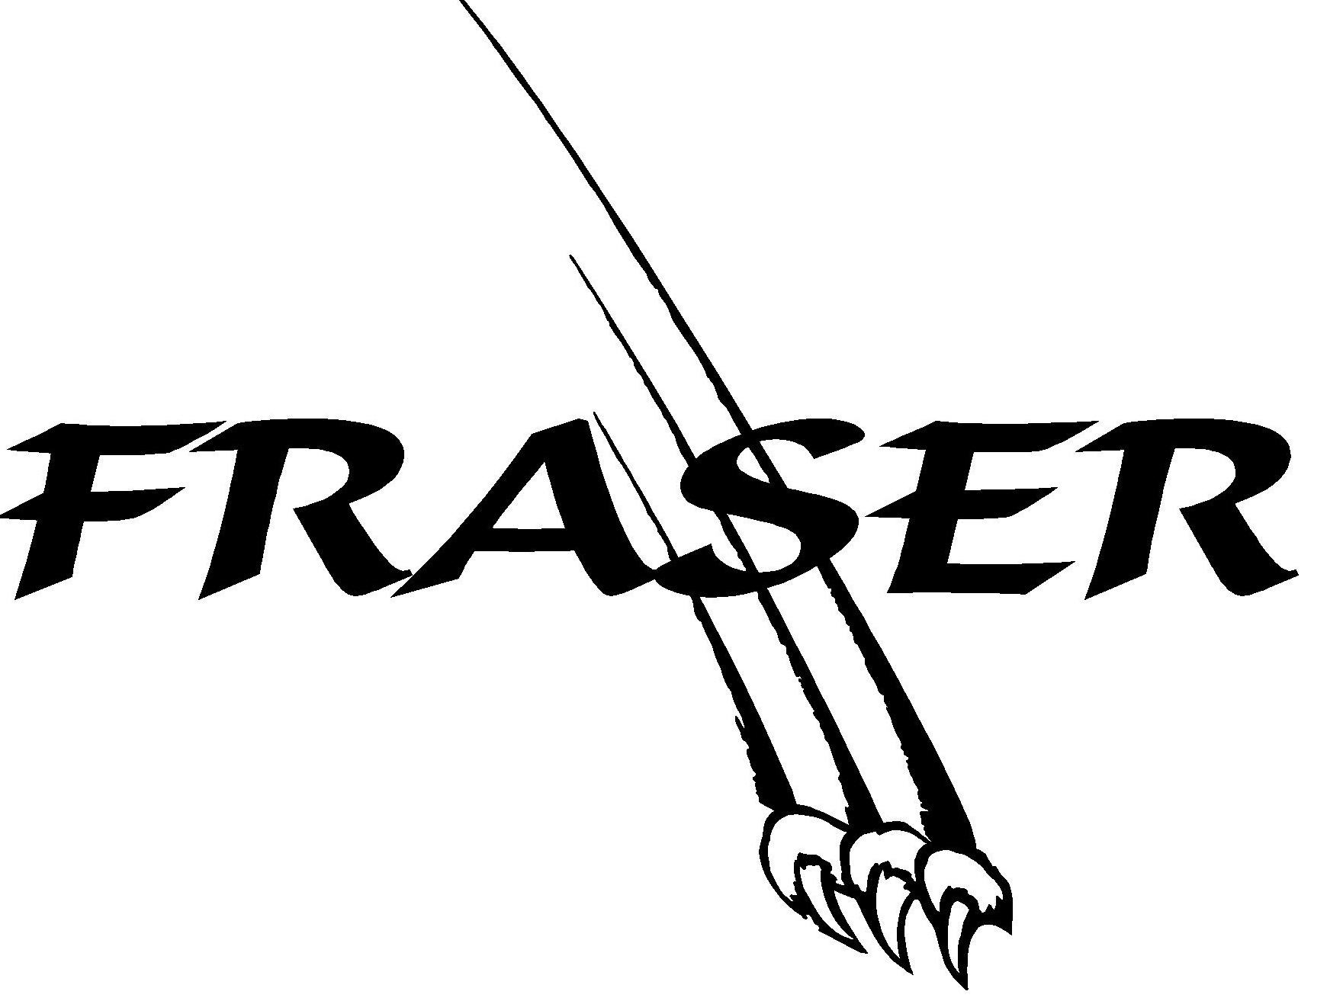
PCS runs a House system that divides the school into three 'teams' that compete throughout the year in areas of sports, behaviour, community support, school spirit, etc.
Each student and teacher is assigned a house team in which they remain in for their entire schooling days at PCS. Students are broken up into three houses, Fraser, Mackenzie, Hudson. Siblings are in the same house. During the course of the year House Meetings may be called to discuss various issues or introduce various activities.
Students receive points for various academic, physical and fun activities around the school.
The intramural program runs through our House System. Teams are created for various intramural activities based on the House Teams. The House that accumulates the most points over the school year will be awarded the House trophy during the closing assembly.
House T-Shirts can be purchased for those who are interested.

Character Development Program
PCS utilizes the Character Development Program for students in Grades 7-12. Students are given character cards based on eight characteristics (Patience, Integrity, Love, Grit,Initiative, Meekness, Servanthood). These cards are entered into monthly draws for various prizes. As well, the student with the most character cards at the end of the month will be the student of the month.
Students that do not receive any late slips, study halls or discipline office visits in a month will receive a food treat (eg. ice cream, pizza)
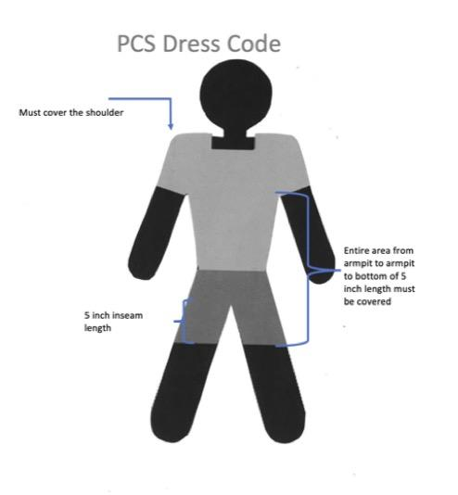
Student Activity Club (Previously known as Student Council)
Students in grades 7-12 have the option of joining the Student Activity Club. The Student Activity Club is coordinated by a teacher and is responsible for organizing various activities around the school such as hot lunches and fun days. It will meet bi-weekly during a lunch hour.

Dress Regulations
Clothing is expected to be appropriate to a working and learning environment.
Our standards of dress and grooming should be in keeping with the high Christian ideals we seek to establish in those who attend Providence Christian School.
- Students must wear clean, tasteful clothing and refrain from wearing inappropriate attire.
- Tops and shirts must cover the shoulder.
- Swimwear must be according to the published directions for the particular swimming activity.
- Indoor shoes must have non-marking soles.
The following items or practices are not acceptable:
- Hats inside the building
- Clothing with inappropriate design, logo, or print (i.e drugs, alcohol, etc)
- Undergarments showing
- Bellies showing
- Tank/Halter tops
- ’Cold shoulder’ garments
- Spaghetti straps
- Shorts or skirts shorter than per posted diagram
- Blankets
Students who do not abide by the dress code will receive a dress-code infraction letter to go home to the parents. It needs to be signed and returned to school.

Service animals
We have learned that the presence of trained or experienced service animals can be a great support for some of our students. We have also experienced that the unscheduled presence of animals that do not serve the specific function of students support can be a real distraction. Allergy concerns have also been raised that give cause to limit animal presence in the building.
Students, teachers, and parents will not be allowed to bring animals on to the school grounds unless their presence has been previously agreed on based on benefits for student and learning support. All arrangements will be made through the office.

School supplies
Kindergarten – grade 6 students’ consumable supplies (eg: markers) will be ordered by the school office. They will be available to the students on Day 1. A list of required renewable supplies and equipment (eg: calculators) that students and families can keep using over the years, is distributed before the summer holidays of each year. A complete supplies list for High school students is distributed at the same time.

Classroom Behaviour
Classroom teachers maintain reasonable behaviour expectations and consequences (both positive and negative) that contribute to the instructional program, classroom harmony, and development of student responsibility. Students will respond appropriately by honouring these boundaries and standards.

Discipline
Students attending Providence Christian School should be prepared to behave and work in such a way that they do not interfere with the learning activities of others in the school. A copy of the Providence Christian School Discipline Policy and Behaviour Management System will be reviewed with all students at the beginning of the school year.
At the beginning of each year copies of the Discipline Policy will be distributed to every family. Parents will discuss the PCS Code of Conduct with their children and witness their signing of it.
The Scriptures command parents to train up children in the way they should go and raise them in the nurture and admonition of the Lord. Fundamental to this task is the removal of negative character traits (lying, stealing, anger, selfishness, laziness, hatred, etc.) and the development of positive character traits (honesty, self-control, lovingkindness, generosity, diligence, etc.)

Respect for Authority Policy
In light of Scriptures we are to honour and respect those in authority over us, “Let every soul be subject unto the higher powers. For there is no power but of God: the powers that be are ordained of God” Romans 13:1. At school, teachers are the authority over the students in place of their parents. All students are to fully submit to the authority over them at all times. There are proper ways to handle situations where the student may think the teacher is in the wrong, but they must submit to and respect authority. Infractions of disrespect as seen by those in authority over the students will result in going to the principal’s office where the situation will be addressed. There may be a call home for the students to be picked up from school. If unable to be picked up the student will spend the day in the principal’s office. If this occurs at the end of the day they will be kept off the bus. If it occurs on the bus they will not be given bus use for a week.

Behaviour Management System
This is a school wide behaviour management program that focuses on increasing positive behaviour and decreasing negative behaviour. It consists of a school wide rewards program for positive behaviour, an individual rewards program for positive behaviour, and a consequence based approach per individual student.
The BMS tallies behaviours on a consistent basis and creates a series of standard responses. Teachers, support staff and parents together support the students in learning academics and in how to interact with peers and adults in a socially acceptable fashion, and to do everything to the honour and glory of God.

Token (Merit) System for Elementary Students (part of the Behaviour Management System)
PCS utilizes a token system where we provide students with a token on a random basis when a child does something well. This could include things like: helping out a peer, assisting the teacher, doing extra work, etc.
Each teacher/teacher’s aide has tokens to hand out to students for various acts of good behaviour. At the end of each month students have the opportunity to redeem their tokens, collected and recorded by the homeroom teacher. Students will also be given the opportunity to “bank” their tokens and redeem them when they have reached a certain target. So, if students choose not to redeem their tokens at the end of the month they can wait and try to redeem them once they have more and reach a higher target. All tokens will be redeemed by the end of the year.

Physical Education Rules
- PCS T-shirt and gym shorts are mandatory. They must be clean, neat, and in good repair.
- Long hair must be tied back.
- Jewelry must be removed for each class.
- Students are encouraged to bring a hat and water bottle to each class.
- Running shoes – no street shoes are allowed. Indoor shoes should be non-marking. Socks or bare feet will usually not be permitted because of the danger of physical injury.
- Students must email or have a note, email, or phone call from parents to be excused from PE. Beyond three days, a doctor's note is required with specific dates of anticipated non-participation.
- For hockey and baseball units students must provide their own stick and glove.
A more detailed list of rules and expectations is provided to the students and parents on the first day
of every school year, and is available on the school website.

Aerosol & Spray Use
Although the use of deodorant with adolescent students does represent positive hygiene practices, the use of deodorant from aerosol cans also represent health and safety issues. The main concern at PCS is that many students do not apply deodorant appropriately, leaving strong scents in the washrooms, hallways, gym, and classrooms. Consequently, use of deodorant should be of personal benefit only and not pervasive in the surrounding environment.

Dudley Locks
All students who have lockers are encouraged to have a lock on their lockers.
- The front office has Dudley locks available to students. No other locks are permitted.
- During the first week of school locks will be signed out to students who request one.
- Records of the lock numbers and combinations will be kept in the office.
- Students pay a $10.00 refundable damage deposit.

Computer Use
If students need access to a computer, they should have the permission of a teacher who can arrange for proper supervision. Kindergarten through grade 9 students have personalized access to shared Chromebooks. Senior High school students work on personally assigned chromebooks.
All Internet traffic is filtered and monitored. All students are expected to comply with the Acceptable Use Policy. Failure to do so will result in consequences as specified in the AUP. Such actions will be determined on a case by case basis and may result in replacement of damaged items at the student’s expense, suspension, or expulsion

Fundraising
Funds raised by students for student activities are managed through the main office. This account is administered by the administrative assistant and is annually reviewed by the principal and the business administrator. All funds raised are distributed to the various activities according to the established formula, shown below. Income is derived from student activity fees, highway cleanup earnings, general donations, auxiliary donations, school board contributions, chocolate bar sales, apple sales, chicken catching, and other fundraisers.
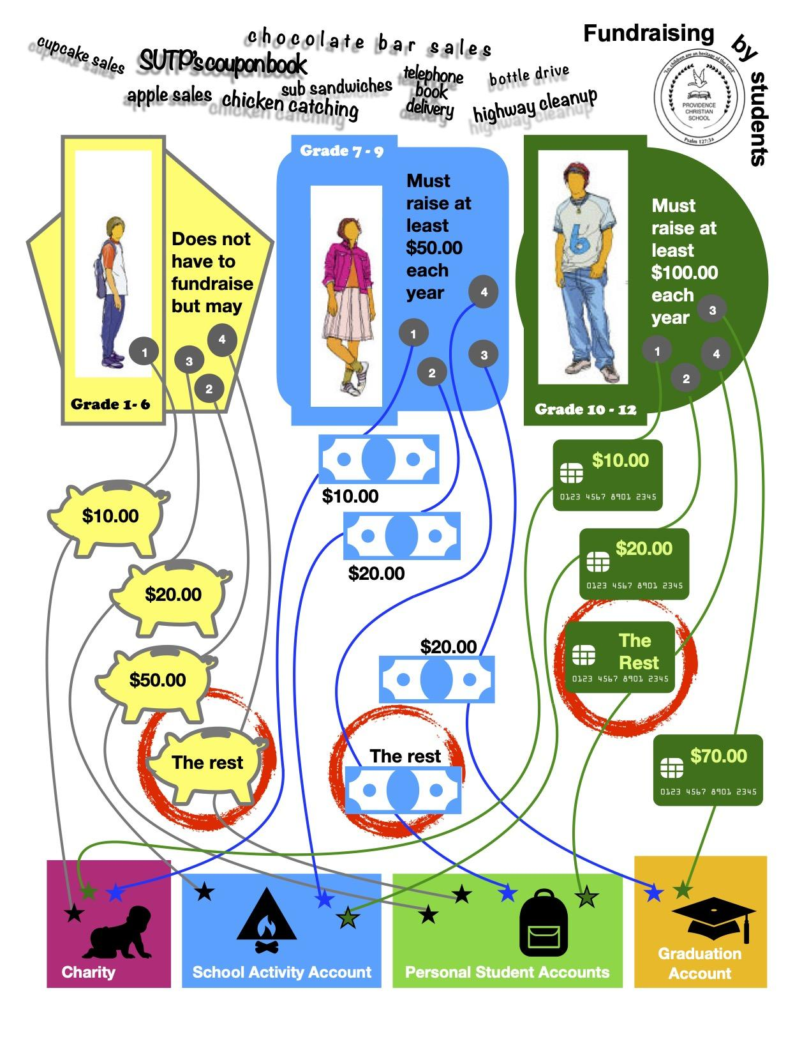
Student  Accounts | Charity  Account | School Activity Account | Grad  Account | Personal Account
Grade 10-12  Must raise at least $100.00 each year. | 1st  $10.00 | 2nd  $20.00 | 3rd  $70.00 | 4th  $ Rest
Grade 7-9  Must raise at least $50.00 each year. | 1st  $10.00 | 2nd  $20.00 | 3rd  $20.00 | 4th  $ Rest
Grade K-6.  do not have to raise any funds but may. | 1st  $10.00 | 3rd  $20.00 |  | 2nd - $50.00  4th - Rest

Electronic Devices Policy
Students are not allowed to use electronic devices, such as cell phones, during the day or at school functions without permission. If there is good reason for a student to use a cell phone, he or she must request permission. Students who choose to use their smartphones to make photos or videos in class or for any other reason without the specific permission of the teacher will be sent to the office.
For clarity, cell phones will not be seen or heard in the classrooms, hallways, bathrooms, gym, playing fields, etc. unless with specific teacher permission. Grade 7 -12 students may use their phones in their lunch rooms during their lunch time (11:40 - 11:50). High School students have the privilege to be in the Library when they do not have to be in class. They may use their phones when they are there.
If students need to be called by parents they must call the office, not the student’s cell phone.
Anyone using an electronic device without permission will:
- have it confiscates by the teacher for the time of the class
- after repeated misuse, have it taken away, brought to the office, and kept there until the end of the day
- at a third occurrence, have it taken for the day and parents will be contacted and alternative arrangements will be made.

Student Laptop Use
School laptops are utilized in high school and in some cases by younger students. Numbered laptops are allocated to eligible students.
Chromebooks are available to K - grade 9 classes. Numbered laptops are allocated to eligible students.
Chromebooks must be returned to the designated storage slots after each use to be plugged in to recharge. Charge cords must remain in place at the charge station. Students in Grades 1-9 may not bring Chromebooks home; however, students in Grades 10-12 may. A laptop or charge cord left in a classroom at the end of the day will be brought to the assistant principal. A toonie ($2.00) will be charged to the student when he/she comes to collect the laptop or charge cord.
Any devices damaged due to carelessness will result in the student paying for the cost of the damage before receiving access to the technology again.
Laptop use during recess time will only be allowed for educational purposes. Any student in Grade 7-9 needing to use a laptop during this time can do so in the study hall room.

Student Email Accounts
High school students also have an email account (firstname.lastname@pcsmonarch.com).
This account will be used for school related purposes and must only be used for that.
Students should check this email regularly.

Student Damage Deposit, etc.
At the beginning of the school year the parents make a refundable ‘Damage Deposit’ for each enrolled child in their family in grade 5 or higher. This deposit is refunded by the office at the end of the year if all school books and other materials are returned without damage. The office will give notice to parents at the end of the year if any damage has occurred that would cause the deposit to not be refunded.

Substance use and abuse
PCS is a smoke and alcohol free environment. Smoking and vaping is not permitted in the building or on school grounds. Use of illegal drugs, marijuana, and alcohol are not permitted in the building or on school grounds.

Driving to School Policy
All students who want to drive to school must request a student parking pass from the office. Students must park in the student parking area. They must have a note from their parents if they are to leave school early, or to leave school property. There must be a permission note from both sets of parents if a student is to drive with another student. Students may not go in other students’ vehicles on school outings, functions, or field trips unless with written permission. Students who drive to school must arrive in class on time. There is zero tolerance on stunting or reckless behavior with a vehicle.
If on two or more occasions a student has proven unable to abide by these expectations he/she may lose the privilege of parking at the school. The principal will decide on this after a meeting with the student.

School Bus Rider Rules
Prior to Boarding the Bus:
- Be 5 minutes early at the designated bus stop so the bus can stay on schedule.
- Be careful in approaching your bus stop. If crossing a street or highway is necessary, wait for the bus to stop and engage the flashing warning lights.
- Stay off the road while waiting for the bus and conduct yourselves in a safe manner while awaiting the bus.
- Do not move toward the bus until the bus comes to a complete stop.

While on the Bus:
- Be courteous to the driver, driver’s assistants, and fellow students.
- Respect other students' personal space:
  - Do not engage in aggressive contact, fighting, pushing, etc.
  - Do not use loud or abusive noise
  - In speech and conduct build other people up, do not put down
- Remain seated at all times. Wait for the bus to come to a complete stop before getting up to disembark.
- No loud talking or laughing is permitted. This could divert the driver’s attention causing an accident.
- Do not engage in horseplay while on the bus.
- Keep hands and heads inside the bus at all times until disembarking.
- Keep aisles clear. Do not put books, packages, musical instruments, or other objects in the aisles.
- Never throw objects in the bus or out of the bus windows.
- Eating is not permitted on the school bus’s regular runs unless at the driver’s discretion.
- Do not litter. Help keep the bus sanitary at all times.
- Smoking and the use of alcohol are strictly forbidden on the school bus.
- Do not leave any of your belongings behind on the bus.
- Help look after the safety and comfort of other bus passengers, and particularly smaller children.
- In case of emergency, students must remain in the bus unless specifically told otherwise by the driver or driver's assistant.
- Be absolutely quiet when the bus nears a railroad-crossing stop.
- Treat the bus with care. Vandalism, damage to seats, etc. must be paid for by the offender.
- Never tamper with the bus or its equipment.

After Disembarking:
- If it is necessary to cross the road after leaving the bus, cross the road in front of the bus, once the bus has come to a complete stop and the stop sign is out.
- Be alert to danger signals from the bus driver.
- Walk well around the bus
- Help young children in disembarking and crossing the road if necessary.

Please note that events of misbehavior or disobedience will result in eventual or immediate suspension of bus riding privileges.

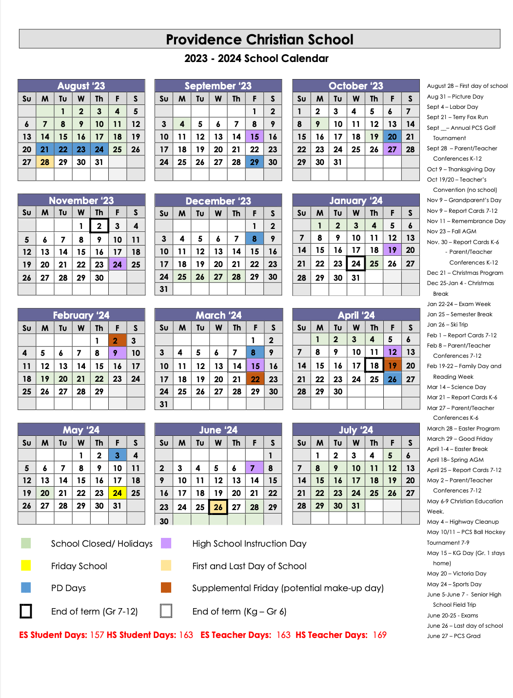

Academic Standards Policy

